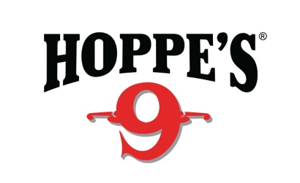

FOR IMMEDIATE RELEASE
Hoppe’s® and Champion® Sponsor Scholastic Action Shooting Program
Brands Serve as SASP Platinum Sponsors for Second Year in a Row
OVERLAND PARK, Kan. – September 8, 2021 – Hoppe’s®, the No.1 name in gun care products, along with Champion® Range & Targets, is pleased to announce both brands have once again partnered with the Scholastic Action Shooting Program (SASP) for 2021. Serving as Platinum level sponsors and donating $10,000 in product and funding, Hoppe’s and Champion have pledged their commitment to helping SASP develop the next generation of competitive shooters.
“Support from the shooting sports industry is a critical part of the Scholastic Action Shooting Program and our youth development mission,” said SASP National Director, Rick Leach. “When brands like Hoppe’s and Champion stand behind us, it shows our community just how important youth participation in shooting sports is.”
Designed to introduce school-age youths to the shooting sports and to facilitate their continued involvement, the SASP provides individuals with opportunities to participate in high-quality team-based sports. Led by trained adult coaches, SASP remains focused on enhancing the personal growth and development of its competitors.
“We look forward to another year of supporting the Scholastic Action Shooting Program,” said Eliza Graves, Hoppe’s and Champion brand marketing manager. “We share a passion for educating kids on safe shooting principles, and SASP has done an incredible job of creating opportunities for young competitors to learn and grow in their shooting skills.”
About Hoppe’s
In 1903, Frank August Hoppe mixed nine chemicals and created the world’s most effective gun cleaner. As a well-trained young soldier, Frank knew that gun care went far beyond just a clean rifle, but actually helped to ensure his safety while on the front lines of battle. Since that time, Hoppe’s has emerged as the leading gun care company, having grown along-side hunters, shooters and soldiers who depend on their firearms every day. It has remained the most trusted name in gun care by advancing and evolving technologies to meet those needs. From the ever popular and versatile No. 9 and the quick and easy BoreSnake, to the marvel of efficiency we call Gun Medic, Hoppe’s is the only name you need to know for firearm cleaning and protection. For more information, visit www.hoppes.com, connect on Instagram at www.instagram.com/hoppesguncare/ or on Facebook at www.facebook.com/hoppesguncare.
About Champion
Champion is a leading provider of quality trap throwers, paper targets, metal targets, clay targets, hearing and eye protection, and shooting systems. Shooting is a fun pastime, and Champion produces a wide variety of products to enhance the experience for shooters of all levels. For more information, visit www.championtarget.com.

Contact: Matt Rice
Sr. Manager Media Relations
Outdoor Products
(913) 689-3713
Matt.rice@VistaOutdoor.com

Product Requests: Will Folsom
Public Relations Associate
Swanson Russell
(402) 437-6404
willf@swansonrussell.com

###

